Quiz 03 Solution

Name: Student ID:

- Look at the map-coloring problem shown below with eight regions, when adjacent regions must have different colors. Indicate how many colors are needed at least and assign each region with one color by R1->C1, R2->C2, and so on. Demonstrate how to solve the problem using most constrained variable and least constraining value.
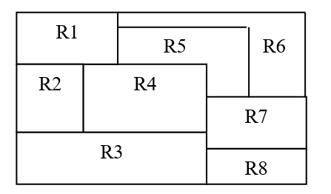
R1: C2; R2: C4; R3: C3; R4: C1; R5: C3; R6: C1; R7: C2; R8: C1;

